How to Create ec2-instance

Go to aws console sign in and log in to aws



Login

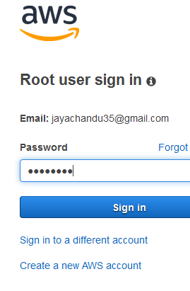

Go to services and select ec2 in aws compute section

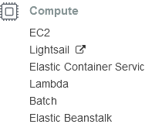

Launch instances

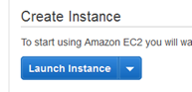

Select free tier and select redhat enterprise linux server

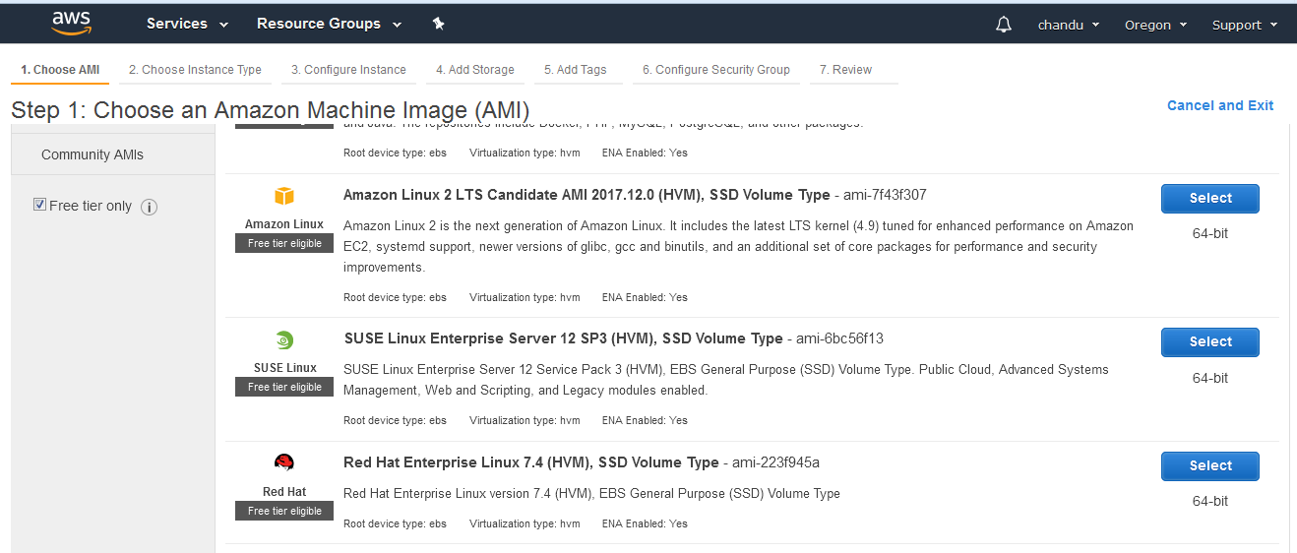

Choose an instance type

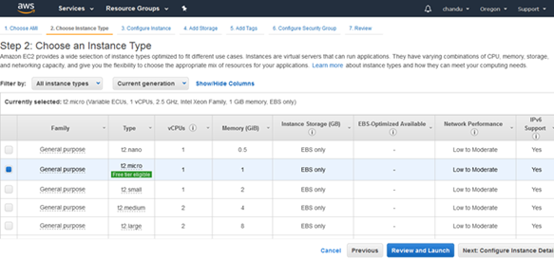

Configure instance type

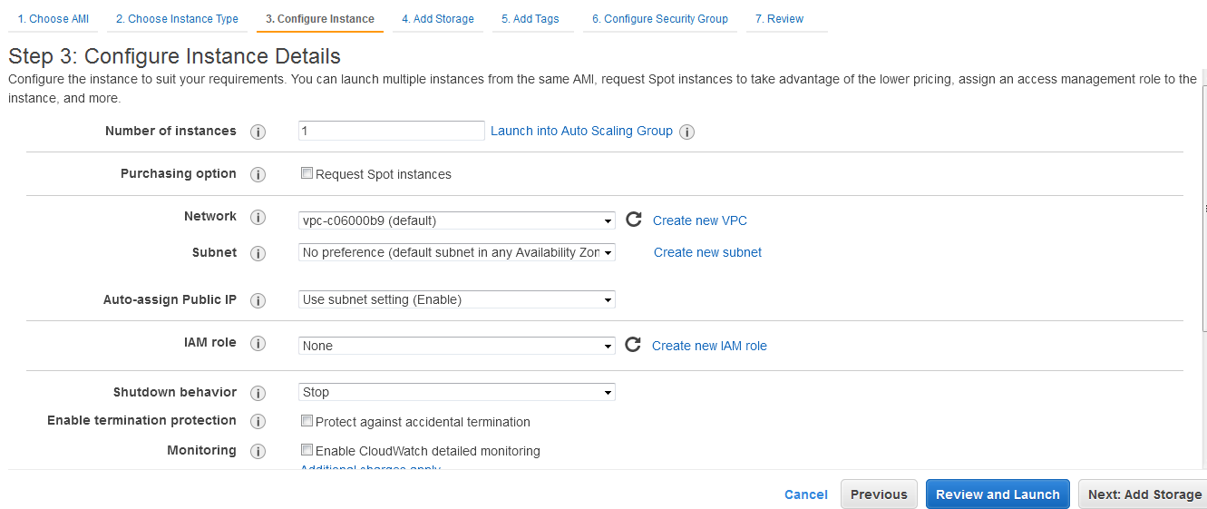

Add storage

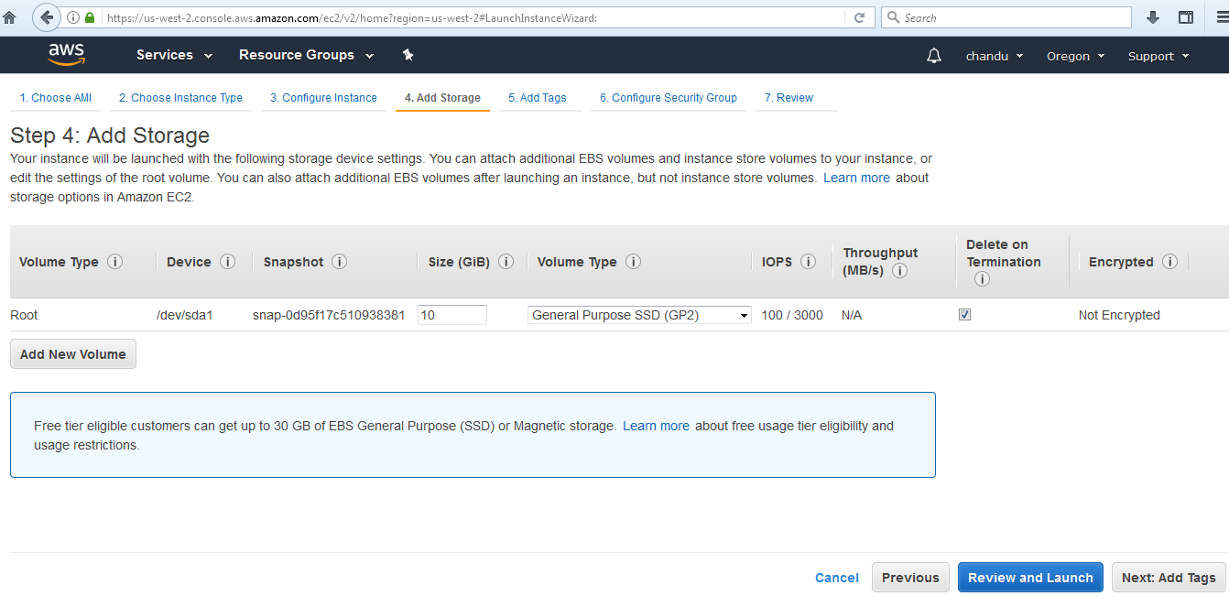

Add tags

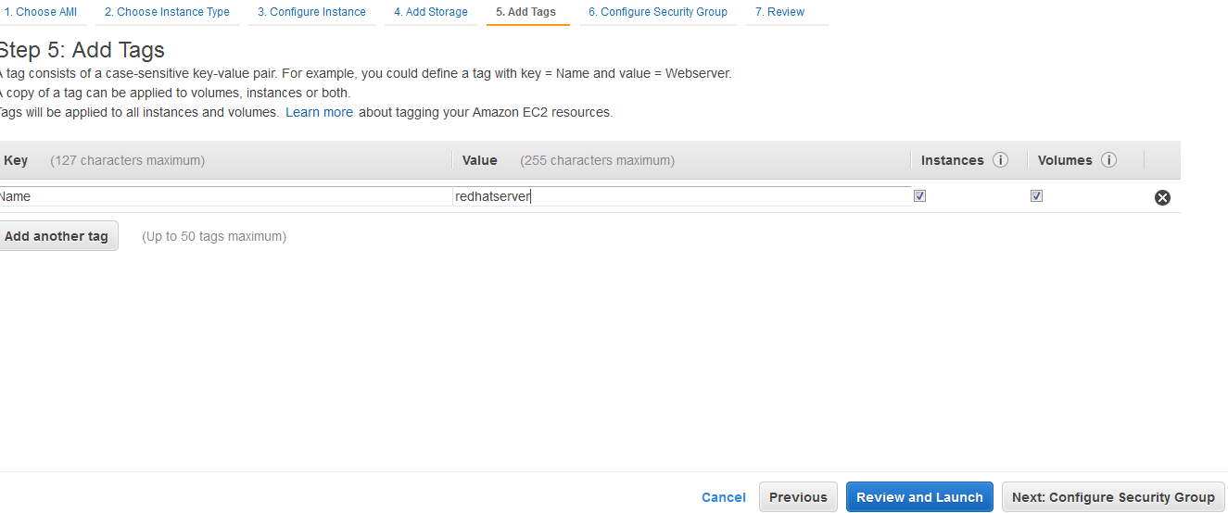

Add security group as ssh – 22 – anywhere

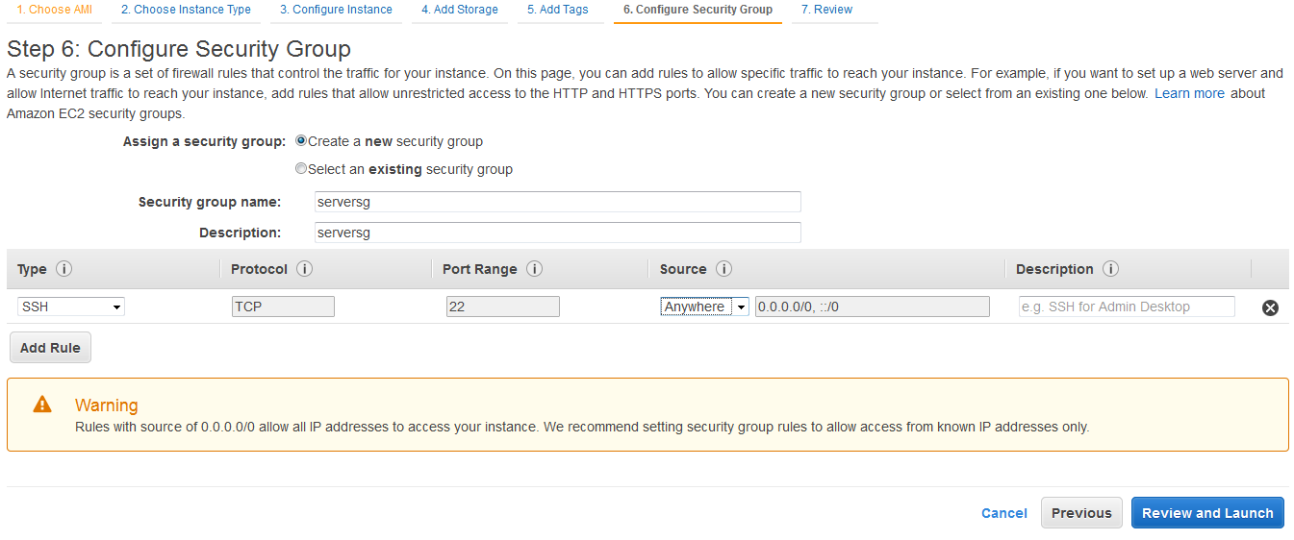

Launch instance

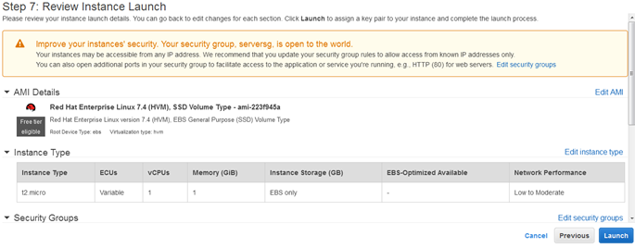

Downloadkey and launch instance

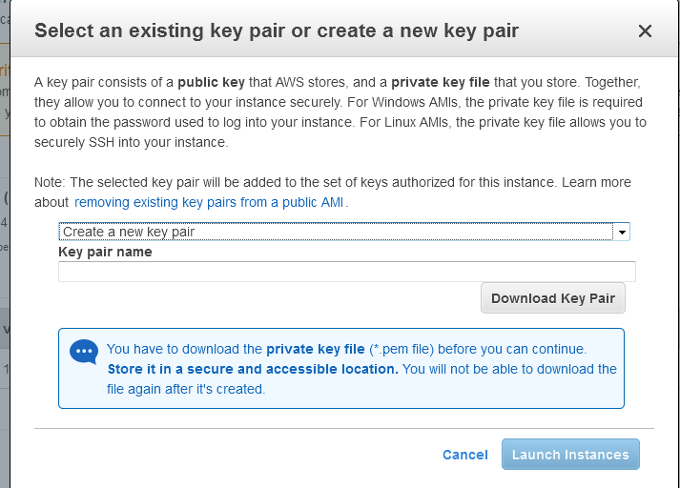

Select view instance

Now instance running in ec2 dashboard

How to connect to redhat server

By using putty you can connect. First download putty in local windows putty download link

https://the.earth.li/~sgtatham/putty/latest/w64/putty-64bit-0.70-installer.msi

putty install and go to -🡪start --🡪puttygen

select putty gen for load key and save as private key

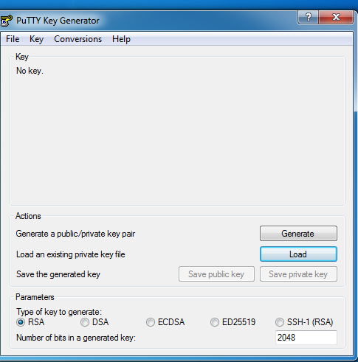🡪 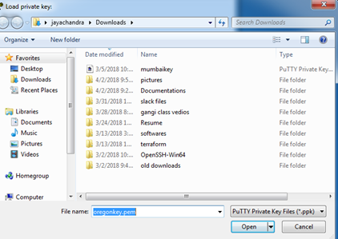 🡪 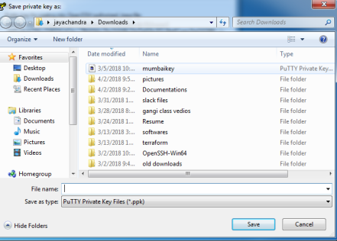Now go to start select putty and add hostname as public ip of instance and saved sesstion as testing and ssh🡪authentication🡪browse key🡪open

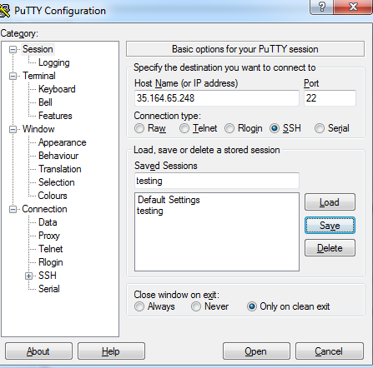 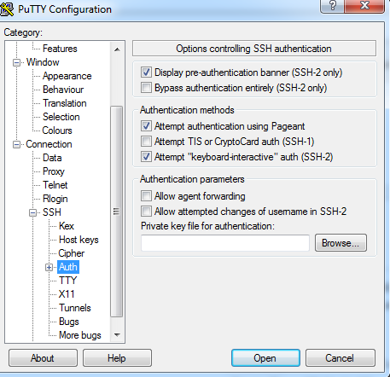

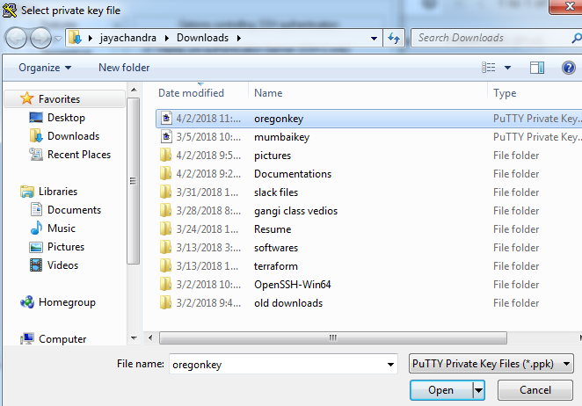

Now you are connecting to ec2 server select yes

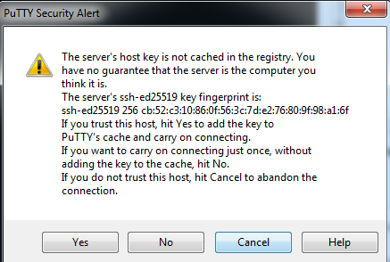

Login as:ec2-user